

DEPARTMENT OF COMPUTER SCIENCE
& APPLICATION
IBM PROJECT
“STUDENT REGISTRATION - MICROSERVICES”

SUBMITTED BY
DELISH KUMAR V(212405832)

BACHELOR OF COMPUTER APPLICATION

Under the guidance of
MR. KAVIN CHARAVATHI V.M - Corporate Trainer
2025–2026

DECLARATION

We,DELISH KUMAR V, MANIKANDAN D, LOKESH KUMAR M and YUKAESH D hereby declare that this project report on “STUDENT REGISTRATION” submitted to the University of Madras in partial fulfillment of the requirement for the award of the Degree Bachelor of Computer Science with Artificial Intelligence under the guidance ofMrs.S.CAROLIN JOSHIBA (HEAD OF THE DEPARTMENT) and Mr. KAVIN CHARAVATHI V.M has not been submitted earlier to any other university or institute for the award of any degree.

DELISH KUMAR V
MANIKANDAN D
LOKESH KUMAR M
YUKAESH D

Place:
Date:

BONAFIDE CERTIFICATE

This is to certify that the project titled “STUDENTS REGISTRATION” is the bonafide work done by DELISH KUMAR V, MANIKANDAN D, LOKESH KUMAR M, YUKAESH D hereby and Second-year students of Jeppiaar College of Arts and Science, Padur, Chennai, in partial fulfillment of the requirements for the award of the Degree of Bachelor of Computer Application 2025-2026.

PROJECT GUIDE: HEAD OF THE DEPARTMENT:
MR. KAVIN CHARAVATHI V.M

DATE:

CONTENTS
S. NO |  | TITLE | PAGE NO
1 |  | ABSTRACT | 01
2 |  | PROBLEM STATEMENT | 01
3 |  | OBJECTIVES | 02
4 |  | SCOPE OF THE PROJECT | 02
5 |  | SOFTWARE REQUIREMENTS | 04
6 |  | FOLDER STRUCTURE | 04
7 |  | SYSTEM ARCHITECTURE | 05
8 |  | DATABASE DESIGN (MongoDB Schema) | 05
9 |  | API ENDPOINTS | 06
10 |  | IMPLEMENTATION AND SOURCE CODE | 06
11 |  | FRONTEND | 08
12 |  | BACKEND | 10
13 |  | TESTING | 12
14 |  | LIMITATIONS | 13
15 |  | CONCLUSION | 14
16 | REFERENCES |  | 15

ABSTRACT:
The Student Registration System is a web-based application developed to simplify and automate the process of student registration. The main objective of this project is to provide an efficient, user-friendly, and secure platform for collecting and managing student information digitally.
The front end of the system is designed using HTML, CSS, and JavaScript, which provides an interactive and responsive user interface. It includes form validation to ensure that users enter correct and complete data such as name, email, password, gender, and course selection. Real-time validation helps reduce errors and improves the overall user experience.
The back end of the application is implemented using Node.js and MongoDB Atlas. Node.js handles server-side operations, while MongoDB is used as a NoSQL database to store and manage student records efficiently. The system performs basic CRUD operations, with a focus on inserting new student data securely into the database.
This project eliminates the drawbacks of manual registration systems such as data redundancy, time consumption, and human errors. The Student Registration System improves data accuracy, enhances accessibility, and provides a scalable solution for educational institutions. Overall, this project demonstrates the practical implementation of full-stack web development concepts and database connectivity.
PROBLEM STATEMENT:
Many educational institutions still rely on manual or semi-digital methods for student registration, which are time-consuming, error-prone, and inefficient. Traditional registration processes involve paperwork, repetitive data entry, and manual verification, leading to data redundancy, inconsistency, and difficulty in managing student records.
Additionally, manual systems do not provide proper validation of student details, increasing the risk of incorrect or incomplete information. Retrieving, updating, or storing student data securely becomes challenging as the number of students increases. These limitations result in increased administrative workload and reduced accuracy.
Therefore, there is a need for an efficient, secure, and user-friendly Student Registration System that automates the registration process, validates user inputs, and stores student data reliably in a database. The proposed system aims to reduce manual effort, minimize errors, improve data management, and provide a scalable solution for educational institutions.
OBJECTIVES:
- To design and develop a web-based Student Registration System for easy and efficient student enrollment.
- To automate the student registration process and reduce manual paperwork.
- To validate student information such as name, email, password, gender, and course to ensure data accuracy.
- To securely store student registration details in a database using MongoDB.
- To implement a user-friendly and responsive interface using HTML, CSS, and JavaScript.
- To reduce data redundancy and minimize human errors during registration.
- To provide quick access to student records for future reference.
- To demonstrate the practical application of full-stack web development concepts.

SCOPE OF THE PROJECT:
The scope of the Student Registration System is to provide a digital platform for registering and managing student information efficiently. The system focuses on automating the registration process and maintaining accurate student records in a centralized database.
The project includes a user-friendly front end that allows students to enter their personal and academic details such as name, email, gender, and course selection. Proper input validation is implemented to ensure data accuracy and completeness.
On the back end, the system uses Node.js for handling server-side operations and MongoDB for storing student information securely. The project supports basic database operations such as inserting and retrieving student records.
The system is designed for use in small to medium-sized educational institutions and can be extended in the future to include features such as login authentication, admin dashboards, record updates, and report generation.
The scope of this project is limited to student registration and does not include advanced modules like fee payment, attendance tracking, or examination management. However, the project provides a strong foundation for building a complete student management system in the future.

SOFTWARE REQUIREMENTS:
- Frontend: HTML, CSS
- Backend: Node.js, Express.js
- Database: MongoDB Atlas
- Tools: VS Code, GitHub.
- OS: Windows/Linux
- Browser: Chrome/Edge
FOLDER STRUCTURE:
Student-Registration-System/
│
├── backend/
│ ├── app.js → Node.js server & MongoDB connection
│ ├── package.json → Project dependencies
│ └── package-lock.json → Dependency lock file
│
├── frontend/
│ ├── index.html → Student Registration Form
│ ├── style.css → Styling and UI design
│ └── script.js → Form validation & client-side logic
│
├── database/
│ └── mongoConfig.js → MongoDB configuration (optional)
│
├── README.md → Project description & instructions
│
└── screenshots/
├── registration-form.png → UI screenshots
└── result-output.png → Output screen
SYSTEM ARCHITECTURE:
Layers:
- Presentation Layer: Dashboard UI (HTML + CSS)
- Application Layer: Express routes handling business logic
- Database Layer: MongoDB schemas for products, transactions, reports
[User] → [Frontend Dashboard] → [Express Server] → [MongoDB Atlas]

DATABASE DESIGN (MONGODB SCHEMA)

USER SCHEMA
Stores login credentials of users.
• username
• password
• createdAt
COURSE SCHEMA
Stores available courses shown in the Courses section
.•CourseName (Python / Java / HTML / C++)
• Description
ASSESSMENT SCHEMA
Stores assessment details related to courses.
• courseName
• assessmentTitle
• status (Completed / Pending)
• createdAt
API ENDPOINTS
- POST /api/products → Add new product
- GET /api/products → View all products
- PUT /api/products/:id → Update product details •DELETE /api/products/:id → Delete product
- POST /api/transactions → Record purchase/sale
- GET /api/reports/inventory → Generate inventory report
- GET /api/reports/transactions→ Generate transaction report

IMPLEMENTATION AND SOURCE CODE:

Step 1: Setup Node.js + Express server.
Step 2: Connect to MongoDB Atlas.
Step 3: Create models and routes.
Step 4: Build frontend dashboard with Bootstrap.
Step 5: Integrate APIs with frontend forms.
Step 6: Test using Postman and browser.

Server.js
require("dotenv").config(); const express = require("express"); const mongoose = require("mongoose"); const bodyParser = require("body-parser"); const path = require("path");

const app = express(); app.use(bodyParser.urlencoded({ extended: true })); app.use(bodyParser.json()); app.use(express.static("public")); // serve frontend files app.use('/assets', express.static(path.join(__dirname)));

/* ================= DATABASE CONNECTION ================= */
const envUri = process.env.MONGO_URI;
const uri = envUri || (() => {
const user = process.env.MONGO_USER; const passRaw = process.env.MONGO_PASS; const host = process.env.MONGO_HOST; const db = process.env.MONGO_DB || "inventoryDB";

if (!user || !passRaw || !host) {
console.error("Missing Mongo configuration. Set MONGO_URI or MONGO_USER/MONGO_PASS/MONGO_HOST in .env");
process.exit(1);
}

const pass = encodeURIComponent(passRaw); return `mongodb+srv://${user}:${pass}@${host}/${db}?retryWrites=true&w=majority`;
})();

mongoose.connect(uri)
.then(() => console.log("✅ MongoDB Atlas Connected"))
.catch((err) => { console.error("❌ Connection error:", err); process.exit(1);
});

/* ================= DASHBOARD ================= */
FRONTEND
<!DOCTYPE html>
<html lang="en">
<head>
<meta charset="UTF-8">
<meta name="viewport" content="width=device-width, initial-scale=1.0">
<title>Student Registration Form</title>
<link rel="stylesheet" href="style.css">
</head>
<body>

<div class="container">
<h2>Student Registration Form</h2>

<form>
<label for="regno">Registration Number</label>
<input type="text" id="regno" placeholder="Enter registration number">

<label for="name">Student Name</label>
<input type="text" id="name" placeholder="Enter student name">

<label for="age">Age</label>
<input type="number" id="age" placeholder="Enter age">

<label for="gender">Gender</label>
<select id="gender">
<option value="" disabled selected>Select gender</option>
<option>Male</option>
<option>Female</option>
<option>Other</option>
</select>

<label for="class">Class</label>
<input type="text" id="class" placeholder="Enter class">

<label for="subject">Subject</label>
<input type="text" id="subject" placeholder="Enter subject">

<label for="email">Email</label>
<input type="email" id="email" placeholder="Enter email">

<button type="submit">Submit</button>
</form>
</div>

</body>
</html>
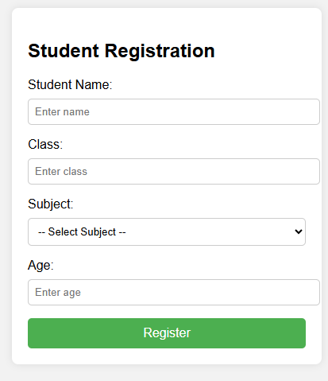

BACKEND
// app.js
const { MongoClient } = require('mongodb');
const readline = require('readline');
const uri =
mongodb+srv://delishkumar28_db_user:<db_ ymfmLT47ajLIsgEN @microservices.lwtvgwk.mongodb.net/?appName=microservices appName=microservices;
const client = new MongoClient(uri);
const rl = readline.createInterface({
input: process.stdin, output: process.stdout
});
async function runCRUDOperations() {
try {
await client.connect();
console.log('Connected to MongoDB Atlas');
const db = client.db('studentDB');
const collection = db.collection('students registrastion');
rl.question('Enter name: ', (name) => {
rl.question('Enter age: ', (age) => {
rl.question('Enter course: ', async (course) => {
const newStudent = {
name, age: parseInt(age), course
};
const insertResult = await collection.insertOne(newStudent);
console.log('Inserted Student ID:', insertResult.insertedId);
rl.close();
await client.close();
console.log('Connection closed');
});
});
});
} catch (error) {
console.error('Error:', error);
await client.close();
}
}
runCRUDOperations();

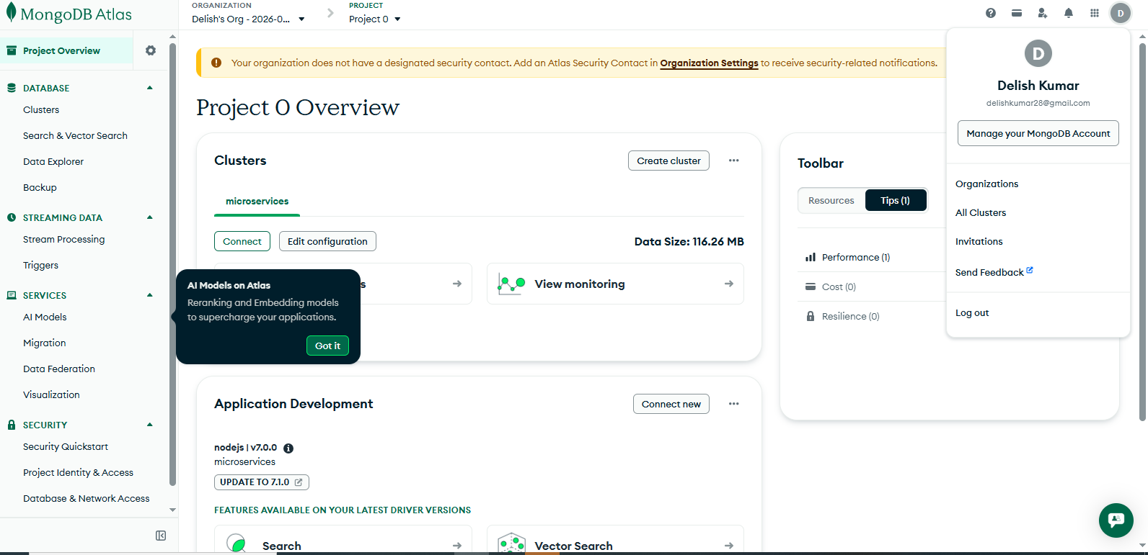
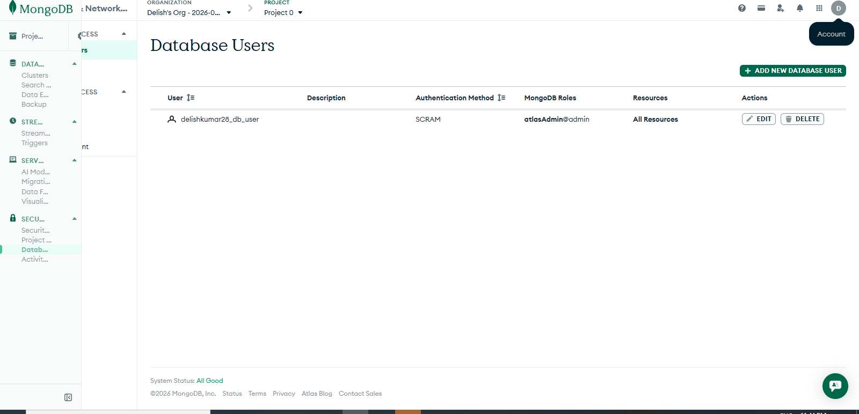
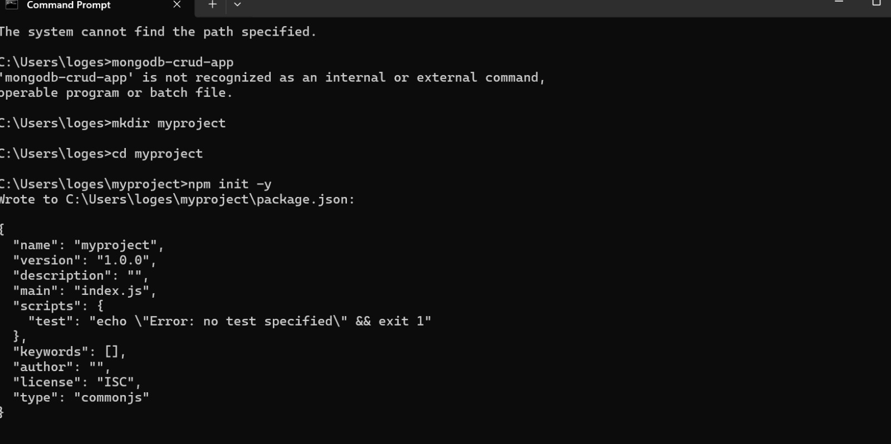

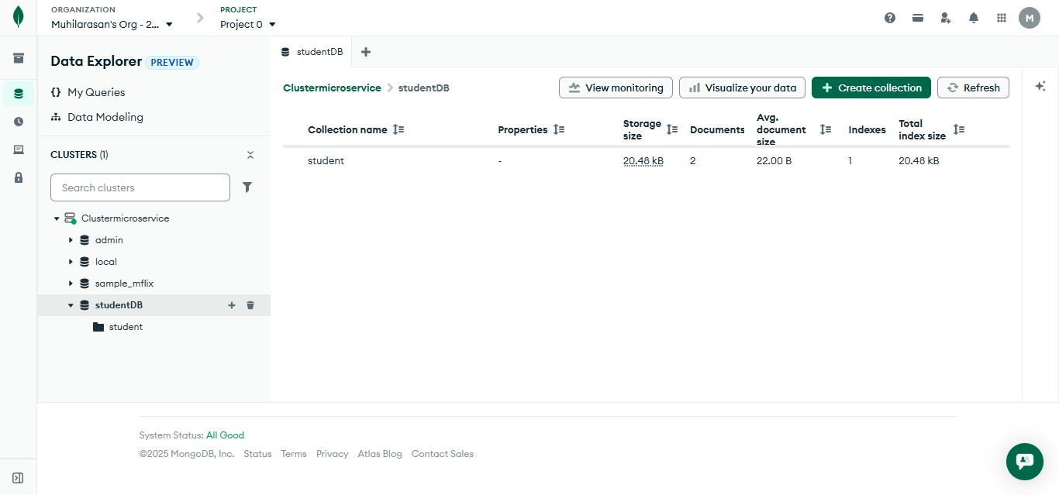

TESTING:
Testing was carried out to ensure that the Student Registration System functions correctly and meets the required specifications. The system was tested for form validation, user input accuracy, and proper interaction between the front end and back end. Various test cases were performed to verify valid and invalid inputs for name, email, password, gender, and course selection. Integration testing confirmed smooth communication between the Node.js server and the MongoDB database. Performance and security testing ensured reliable data storage and safe handling of user information. All identified issues were resolved, and the system was found to be stable, accurate, and user-friendly.
LIMITATIONS
The Student Registration System has certain limitations in its current implementation. The system supports only basic student registration functionality and does not include advanced features such as user login, role-based access, or admin dashboards. Data modification and deletion options are limited, and the system does not provide report generation or data export facilities. It depends on a stable internet connection and proper server availability to access the database. Security features such as data encryption and advanced authentication are minimal. However, these limitations can be addressed in future enhancements.

CONCLUSION:
The Student Registration System was successfully developed to automate and simplify the process of student enrollment. The system provides a user-friendly interface for entering student details and ensures proper validation of data before storing it in the database. By integrating front-end technologies such as HTML, CSS, and JavaScript with back-end technologies like Node.js and MongoDB, the project demonstrates the practical implementation of full-stack web development. The system reduces manual effort, minimizes errors, and improves efficiency in managing student records. Overall, the project meets its objectives and serves as a strong foundation for developing a complete student management system in the future.
REFERENCES:
GITHUB

